**OBJECT ORIENTED DEVELOPMENT**

**CPSC 60000**

**Group Assignment 2**

**New Group 6**

**Team Members : Shaik Jameel Basha**

**Arish Jayavictor**

**PROF : Fadi Wedyan**

Table of Contents

Introduction 3

Section 1: Objectives, questions and metrics 3

Section 2: Description of the project 4

Section 3: Tool used 7

Section 4: Implementation 7

Section 5:Results and findings 23

References 24

**Effect of code bad smells on testability**

# Introduction

Code bad smells are defied as the indicators of the mistakes or the violations in the software development. This occurs often due to the improper coding, wrong decisions in designing, which affects the quality of the software. The proper understanding of the relationship between the code bad smells and modularity are very important for developers to code effectively. This report aims in discussing the effects of code bad smells on modularity in developing the software projects. The approach used for the analysis is the Goal-Question-Metric (GQM) (Lacerda, 2020).

# Section 1: Objectives, questions and metrics

**Objectives**

The main objective of this study is to analyse the impact of code bad smells on the modularity of the software projects. This research study also helps in understanding the effects of code bad smells in the coupling and the cohesion metrics. This has a huge impact on the modularity of the project.

**Questions of GQM approach**

The research questions related to the GQM approach are

* What is the connection between the existence of code bad smells and modularity metrics in the software projects?
* Do classes containing code bad smells exhibit different coupling and cohesion values when compared to classes which are not affected?
* How different types of code bad smells are related to the modularity metrics?

**Metrics according to the GQM approach**

The following metrics are used for this study according to the GQM approach

* Coupling Metric
* Cohesion Metric

The coupling metric is used to measures the amount of interdependence between classes within a software project.

The cohesion metrics is used to measure the extent to which elements inside a class belong to each other. These metrics will be obtained using the CK-code metrics tool, allowing us to quantitatively assess the modularity of the selected software projects (Aversano, 2020).

# Section 2: Description of the project

**Description of the project**

For the study, 10 projects are selected form the Github and used for the analysis. The projects include

* Hospital management system
* Shop management system
* Super market management system
* Warehouse management system
* Bank management system
* ATM - machine
* Console card game
* Counter program
* Meal management system
* Queue management system

|  |  |  |
| --- | --- | --- |
| **Project** | **Link** | **Description** |
| Hospital management system | [**https://github.com/dinushchathurya/HospitalManagementSystem**](https://github.com/dinushchathurya/HospitalManagementSystem) | The hospital management system is the software application which is developed to regulate and automate the administrative operations. The operations include patient registration, scheduling the appointments, managing the medical records, and reporting the operations. |
| Shop-management system | [**https://github.com/deba1/Shop-Management-System**](https://github.com/deba1/Shop-Management-System) | The shop management system is a software solution which is developed according to the retail business including the shops, boutiques, and stores. This also acts as a tool for managing the inventory, sales, purchases, customer relationships, and managing the employees. Also, the system may include features for generating invoices, tracking performance of sales, managing suppliers, and analyzing the recent business trends (Mhawish, 2020). |
| Super marker management system | <https://github.com/ahmedmbutt/SuperMarketManagementSystem> | The supermarket management system is a complex software application developed to support the efficient operation of supermarkets and grocery stores. It includes the features like inventory management, sales and billing, point-of-sale (POS) functionality, customer relationship management (CRM), managing the vendors, and scheduling the tasks of the employees. |
| Warehouse management system | <https://github.com/zkcplk/Depo-Yonetim-Sistemi> | The warehouse management system is a software solution designed to optimize the storage, maintenance, and distribution of goods within a warehouse or distribution centre. It involves the functionalities like tracking the inventory, managing the orders, picking and packing, receiving and shipping, and warehouse layout. The system may utilize technologies like barcode scanning, RFID (Radio Frequency Identification), and automated storage and retrieval systems (AS/RS). |
| Bank Management System | <https://github.com/jeremyjosephabraham/J-A-Bank-Management-System> | The bank management system is a software platform developed to ensure the efficient operation in the banking institutions, which includes the commercial banks, credit unions, and financial institutions. It also includes the features like account management, transaction processing, loan management, customer relationship management (CRM), and regulatory compliance. The system may also provide the online banking services, mobile banking applications, and collaborating with the third-party payment systems (Cairo, 2020). |
| ATM machine | <https://github.com/rajyash1904/ATM-Machine> | The ATM (Automated Teller Machine) project involves the process of developing software for self-service banking tasks. The users can perform different banking transactions like withdrawing cash, depositing funds, transferring money, and checking account balances. The system collaborates with a bank's database to securely process transactions and manage customer accounts. |
| Console card game | <https://github.com/GitPaulo/console-card-game.git> | The Console Card Game project is used to create a text-based card game which is played in a console environment. Players engage in card-based game, and follow rules specific to the chosen card game (Cairo, 2020). |
| Counter program | <https://github.com/Casasola98/Counter-Program> | The Counter Program project is used to count occurrences or events in a systematic manner. The users can increment or decrement the counts, track multiple counters at the same time, and reset counts as required. |
| Meal Management System | <https://github.com/Muhtadir/Meal-Management-System> | The Meal Management System project is used to regulate the management of meals and dietary plans for individuals or groups. The users can create, schedule, and track meals according to their dietary preferences, nutritional requirements, and meal times. |
| Queue-Management-System | <https://github.com/Naimcse56/Queue-Management-System> | The Queue Management System project is used to manage queues or lines effectively in different settings like banks, hospitals, or service centres (Verwijs, 2021). |

# Section 3: Tool used

**Tool used**

The main tool used in this analysis is the JDeodorant. JDeodorant is an Eclipse plug-in tool which is designed to help the developers in finding and modifying the code smells in Java projects. It provides a user-friendly interface within the Eclipse Integrated Development Environment (IDE), which will be very convenient for developers to evaluate and improve the quality of their code. The main features of the tool are detecting the code smell, visualising the detections and customising the configurations.

JDeodorant's provides a proper user interface and continuous integration with Eclipse which helps the developers to incorporate code smell detection and refactoring into their workflow. By using different types of detection algorithms, JDeodorant gains effective analysis capabilities, helping the developers to find different types of code smells and overcome them properly. By considering the visual feedback and automated refactoring systems in real-time, JDeodorant helps the developers maintaining the quality of code throughout the development process (Verwijs, 2021).

# Section 4: Implementation

**Types of bad smells**

**God Class:** In management systems, this class is used to manifest as classes that help in handling the multiple functionalities like handling all aspects of inventory management, customer management, or transaction processing within a single class.

**Long Method:** Long methods are complex and long functions or procedures which are difficult to understand and maintain. In management systems, this method is used as functions responsible for processing complex transactions, generating reports, or handling business logic with more conditional statements.

**Feature Envy:** Feature Envy occurs when a method or function in one class accesses and manipulates data from another class in some cases. In shop management systems, this method could manifest as classes that depend on data from other classes, reducing the modularity.

**Duplicated Code:** Duplicated Code refers to similar code parts that appear in multiple places within the codebase. In management systems, this is identified when similar functionalities are implemented in different parts of the system, increasing the inconsistency.

**1.** **Hospital management system**

**Method occur: Long Method**

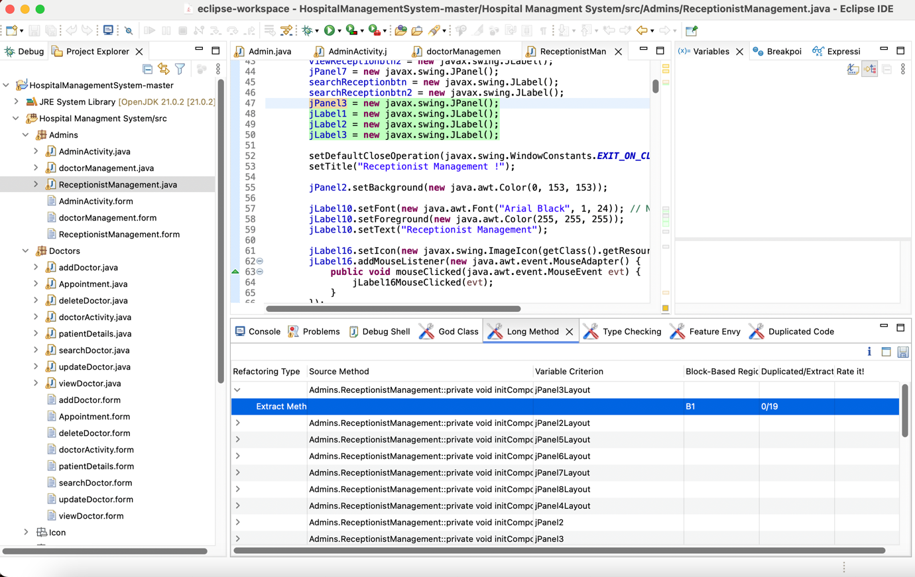

Figure 1 Hospital management system – Long method

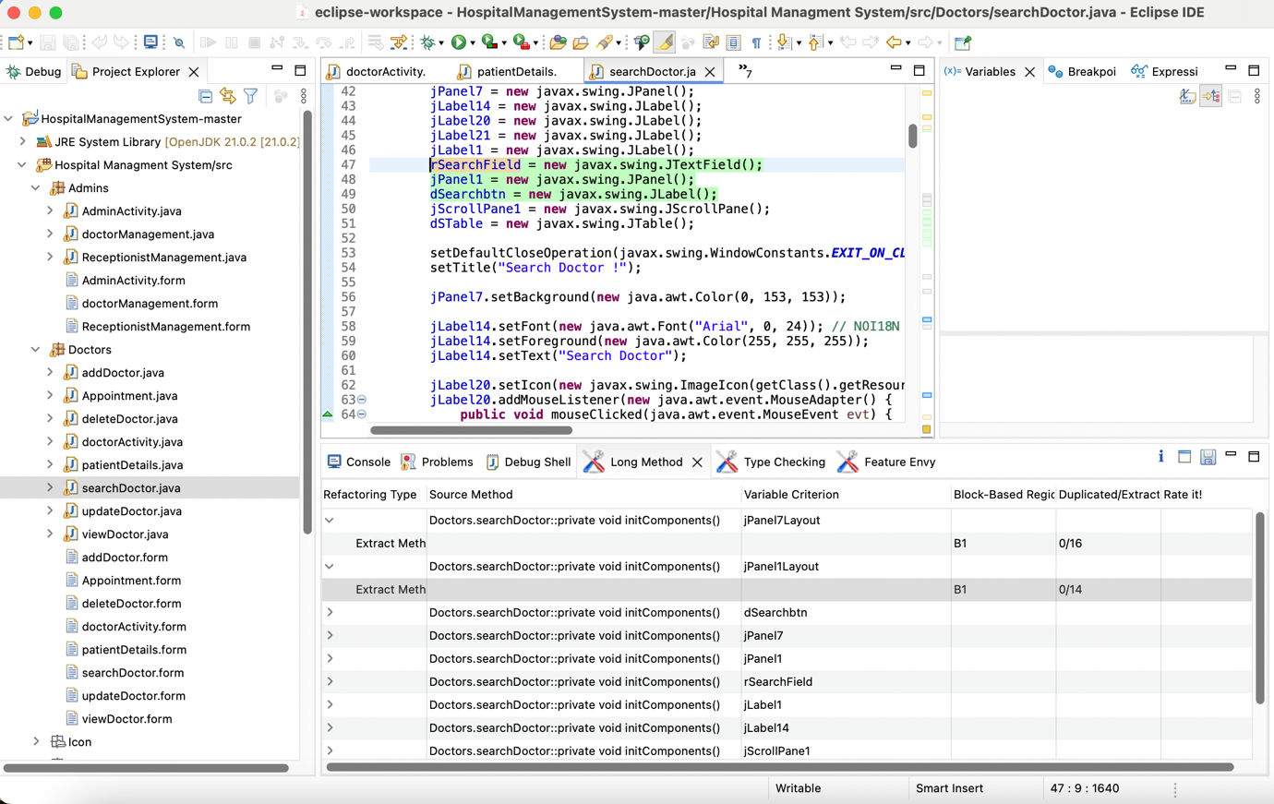

Figure 2 Hospital management system – searchDoctor class

**Method occur: God class**

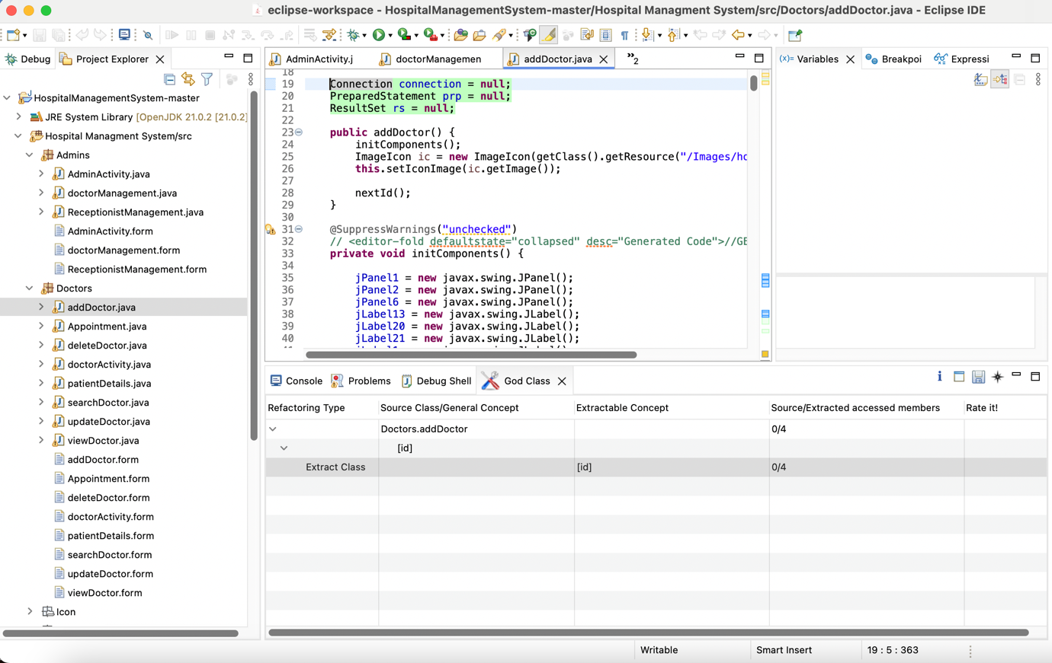

Figure 3 Hospital management system – God class

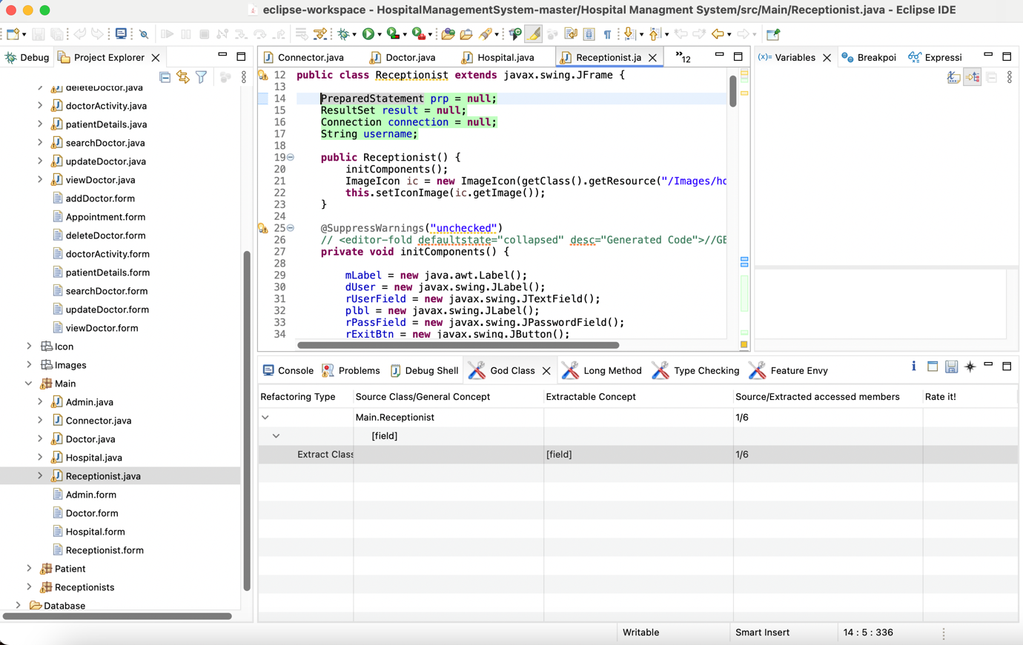

Figure 4 Hospital management class – Receptionist class

**2. Project: Shop-management system**

**Method occur: Long Method**

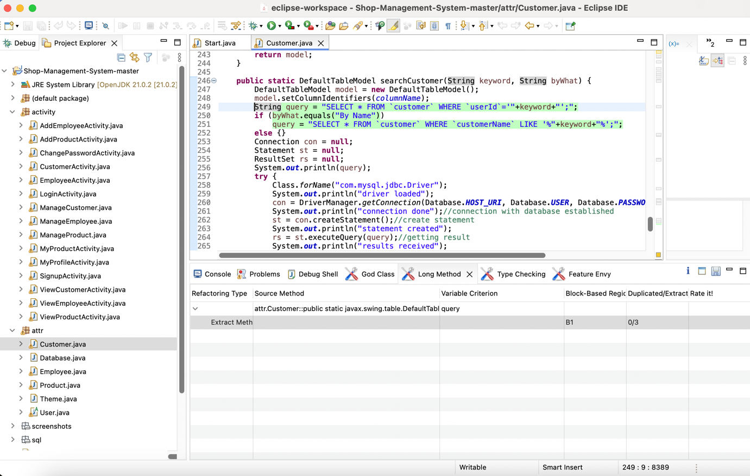

Figure 5 Shop management system – Long method

**Method occur: God Class**

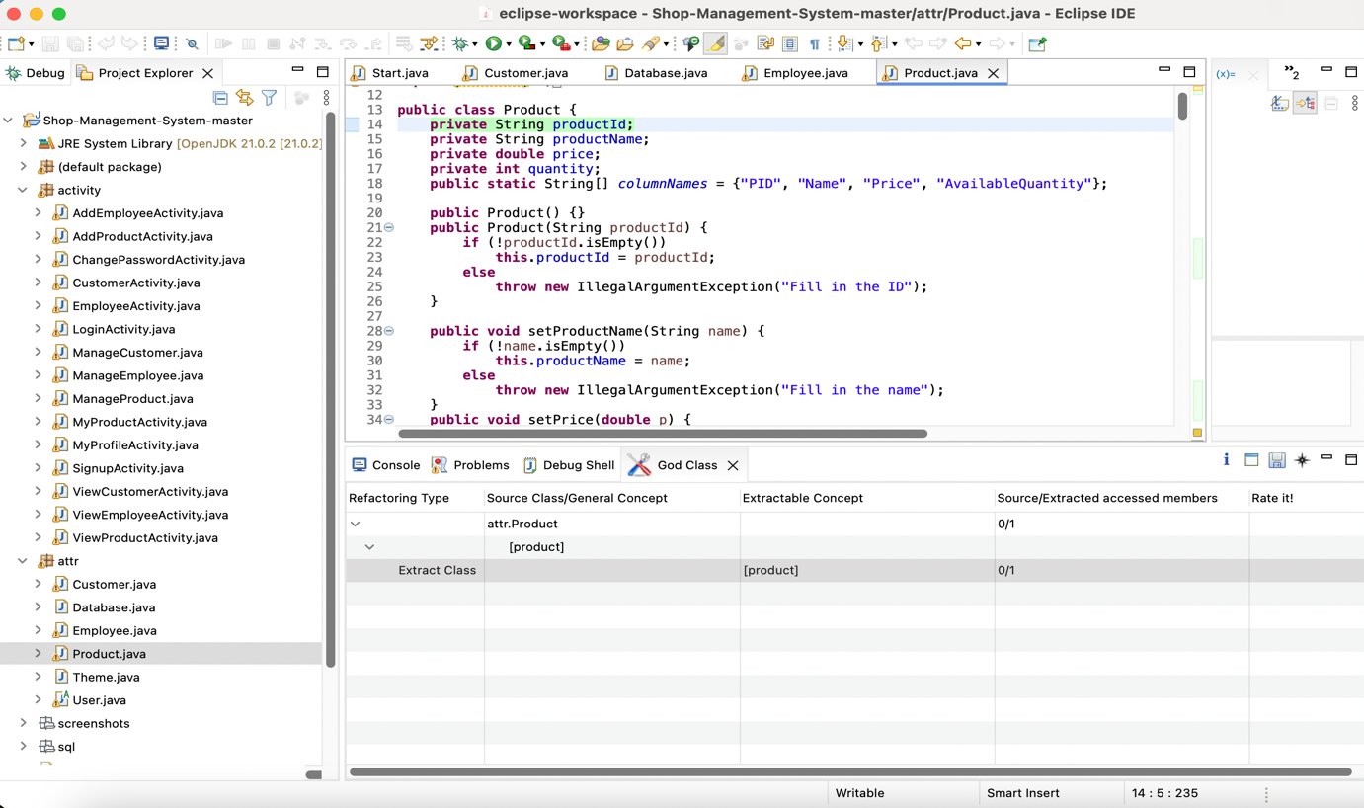

Figure 6 Shop management system – God class

**3. Project: Super marker management system**

**Method occur: Long method**

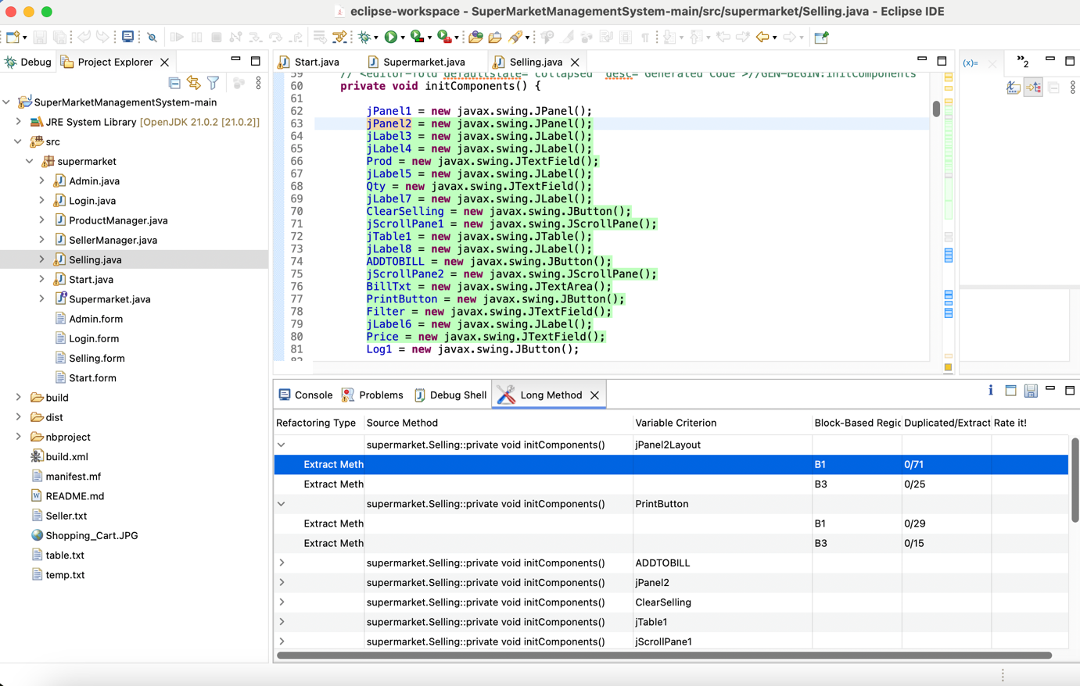

Figure 7 Supermarket management system – Long method

**Method occur: God Class**

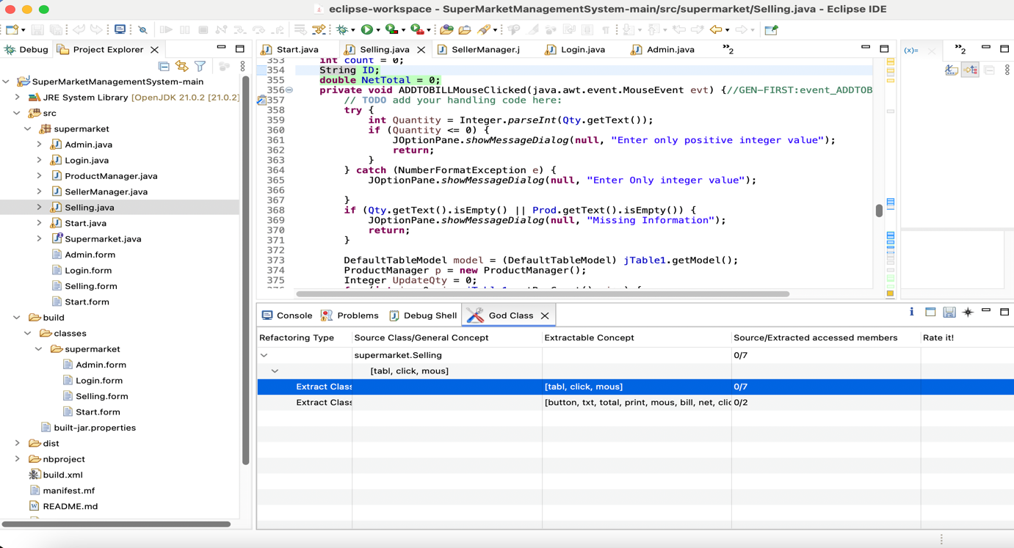

Figure 8 Super market management system – God class

**4. Project: Warehouse management system**

**Method occur: God class**

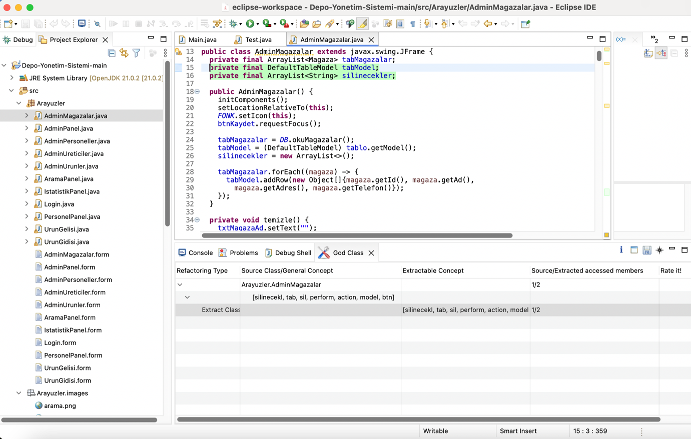

Figure 9 Warehouse management system – God class

**Method occur: Long Method**

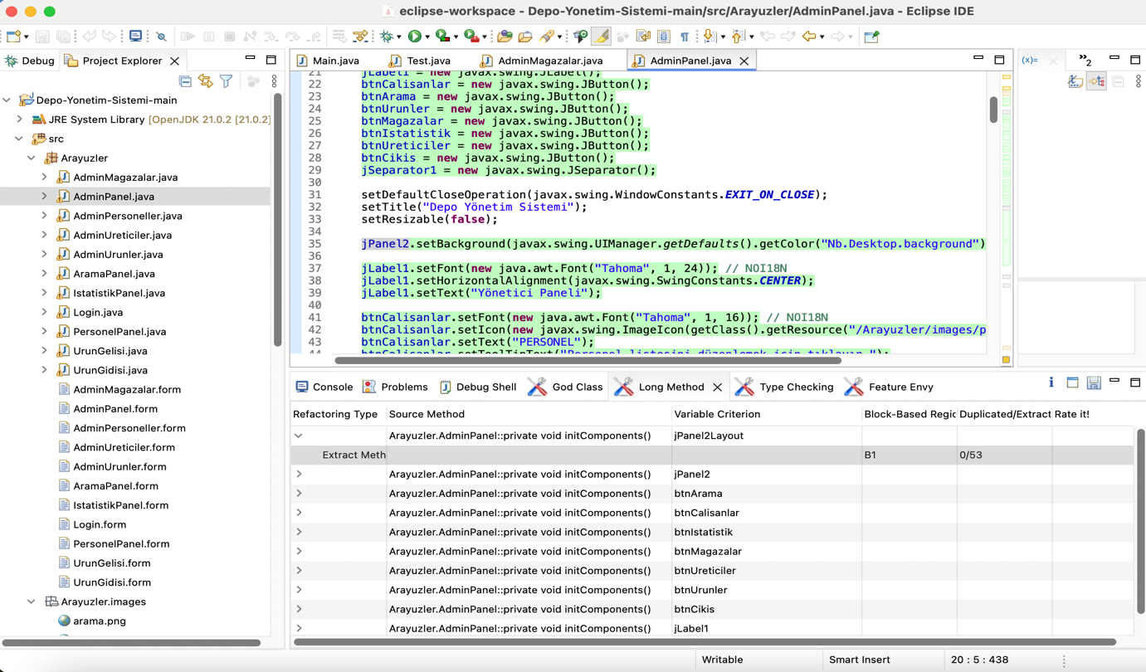

Figure 10 Warehouse management system – Long method

**5. Project title: Bank Management System**

**Method occur: God class**

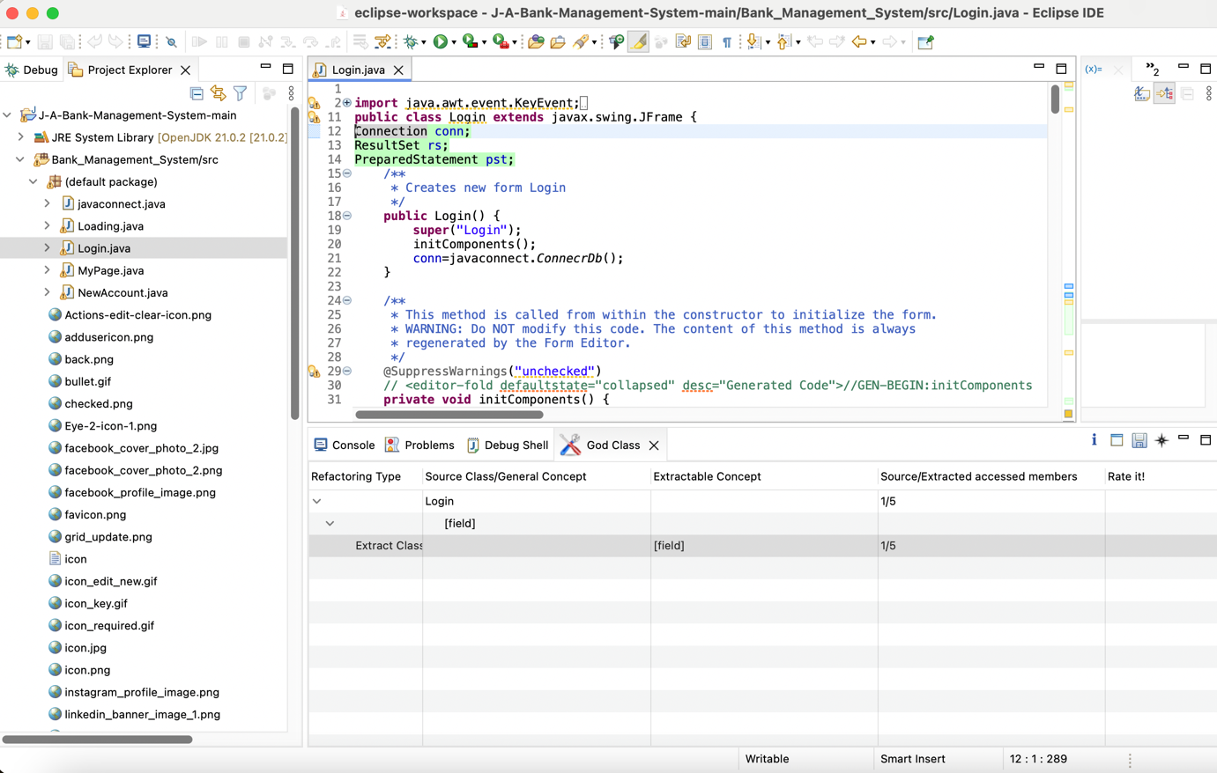

Figure 11 Bank management system – God class

**Method occur: Long method**

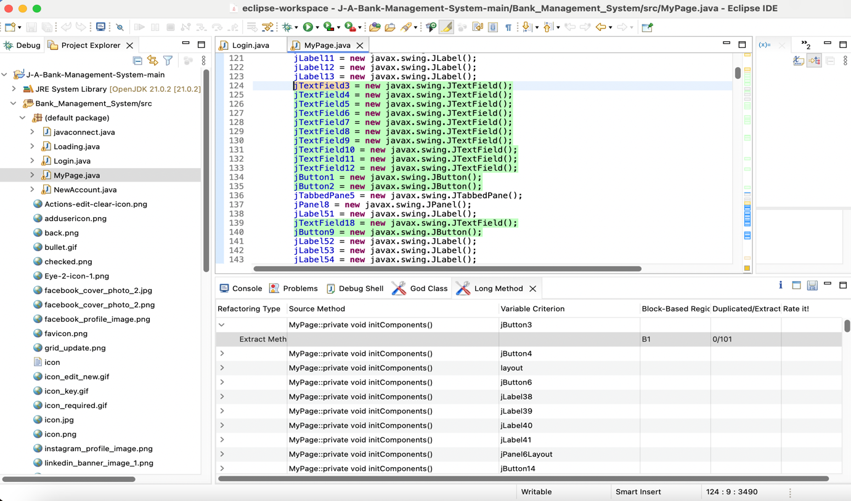

Figure 12 Bank management system – Long method

**6. Project title : ATM machine**

**God Class**

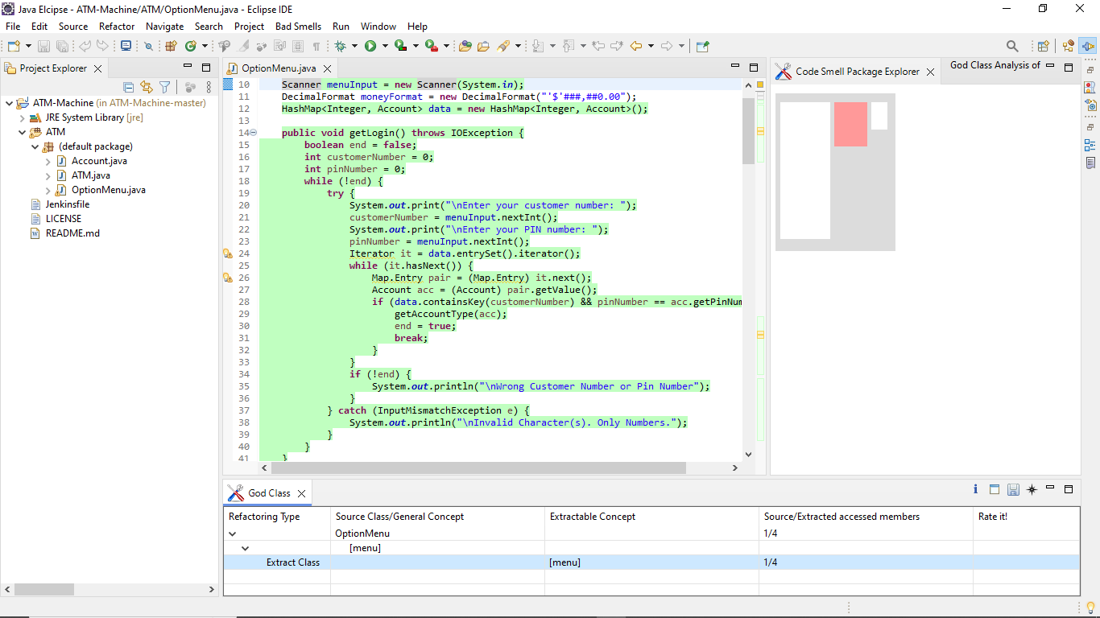

Figure 13 ATM machine – God class

**Long Method**

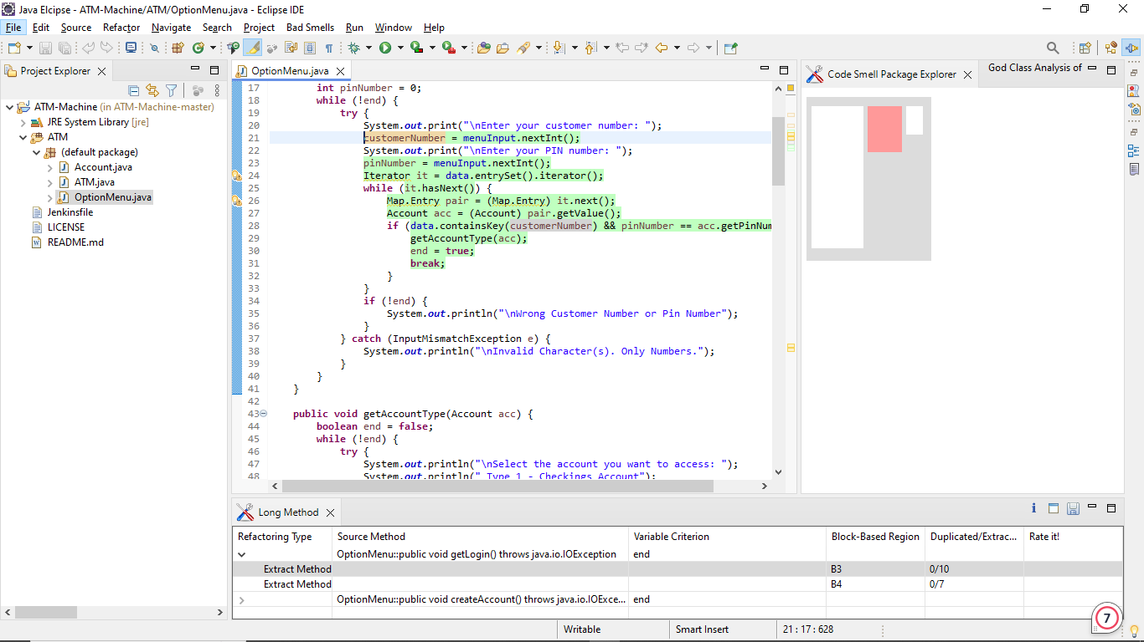

Figure 14 ATM machine – long method

**Feature Envy**

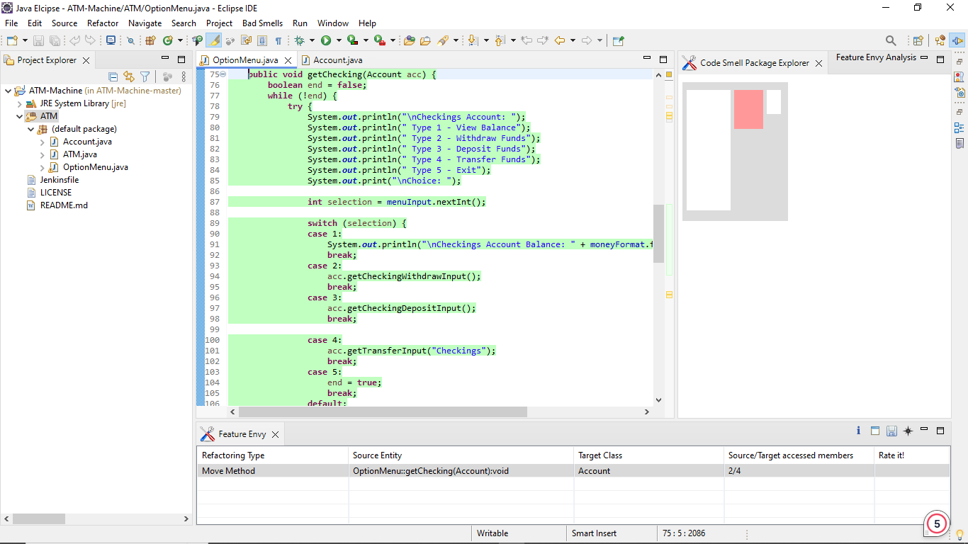

Figure 15 ATM machine – feature envy

**7. Project title: Console card game**

**God Class**

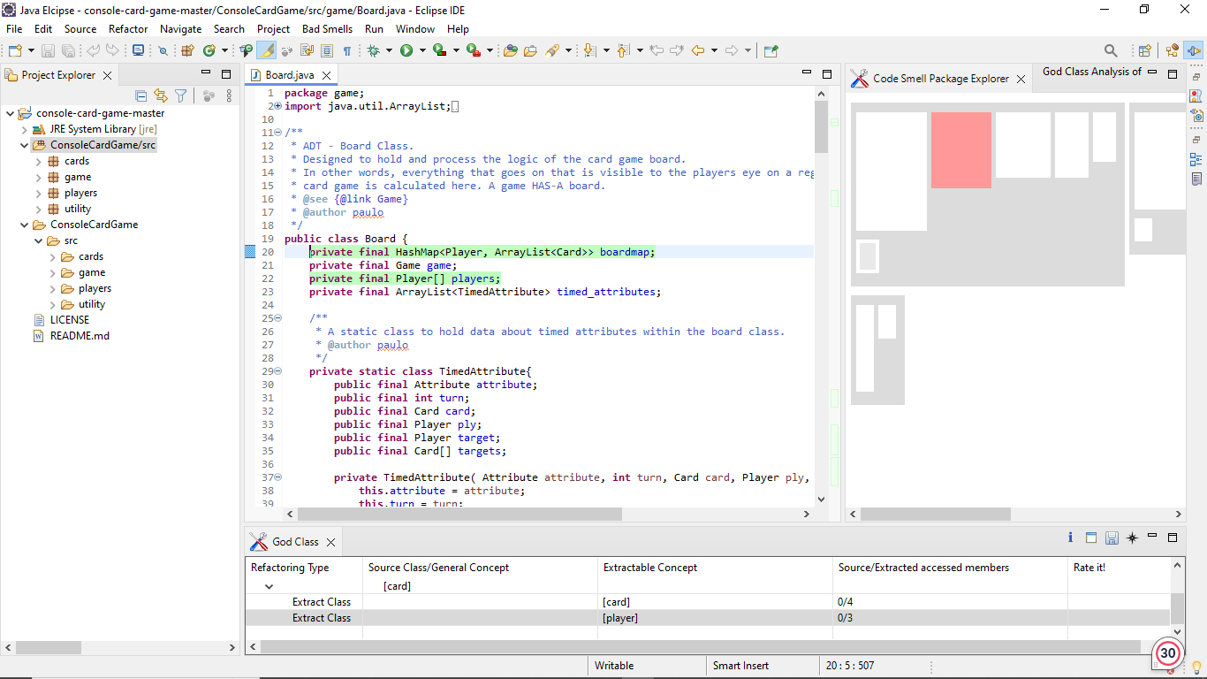

Figure 16 Console card game- god class

**Long Method**

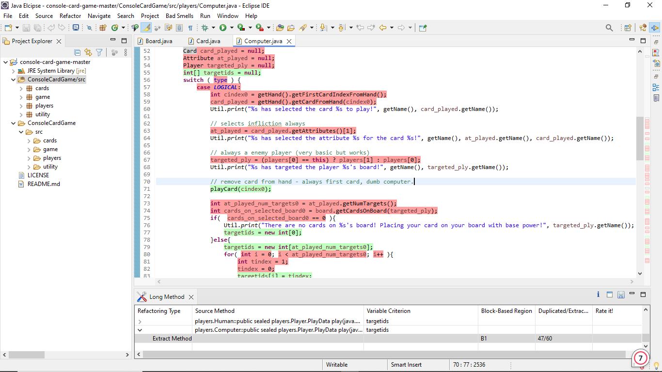

Figure 17 Console card game –long method

**Type Checking**

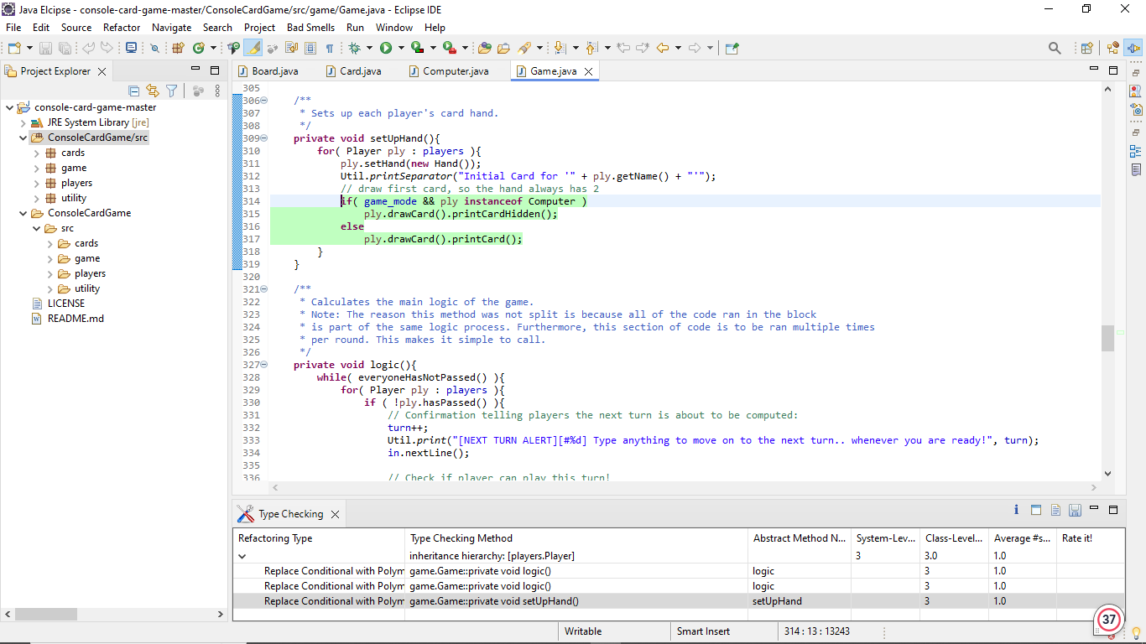

Figure 18 Console card game- type checking

**Feature Envy**

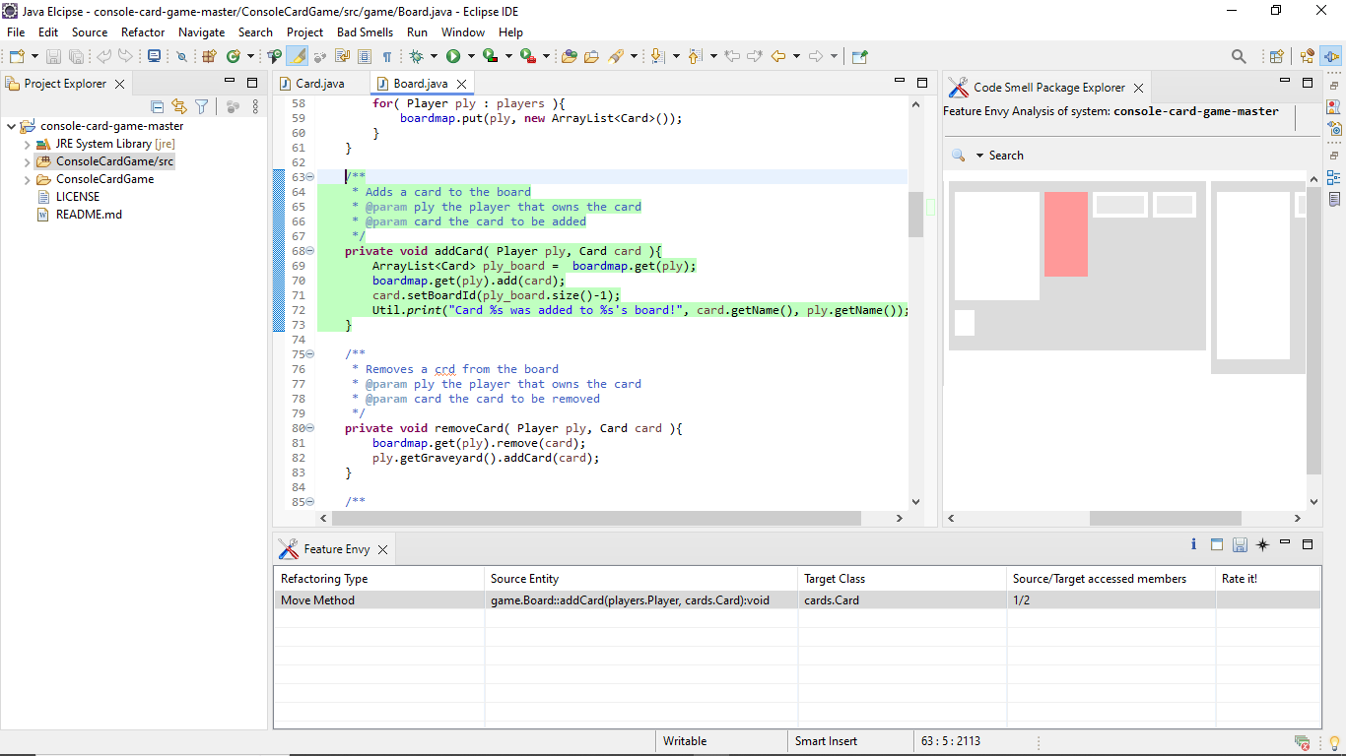

Figure 19 Console card game – feature envy

**8. Project title: Counter program**

**God Class**

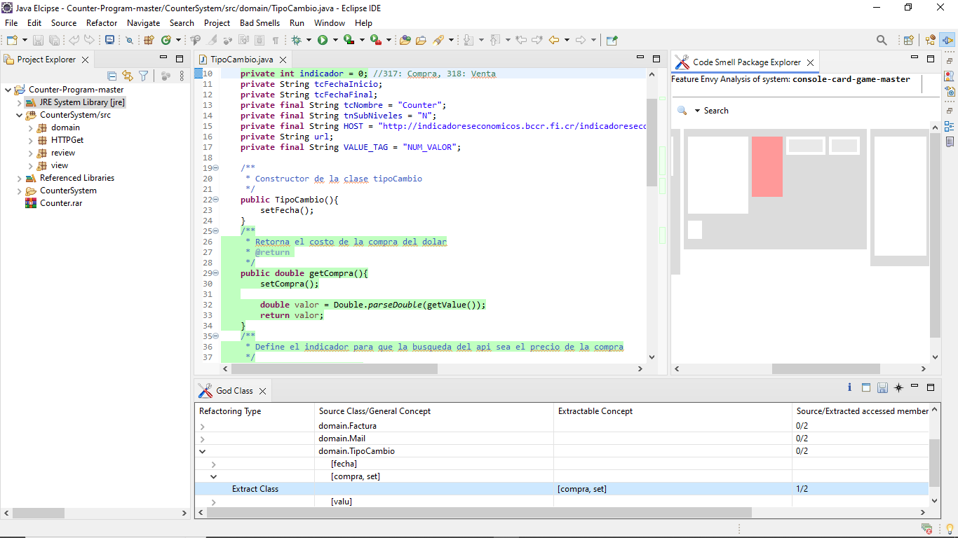

Figure 20 Counter program - god class

**Long Method**

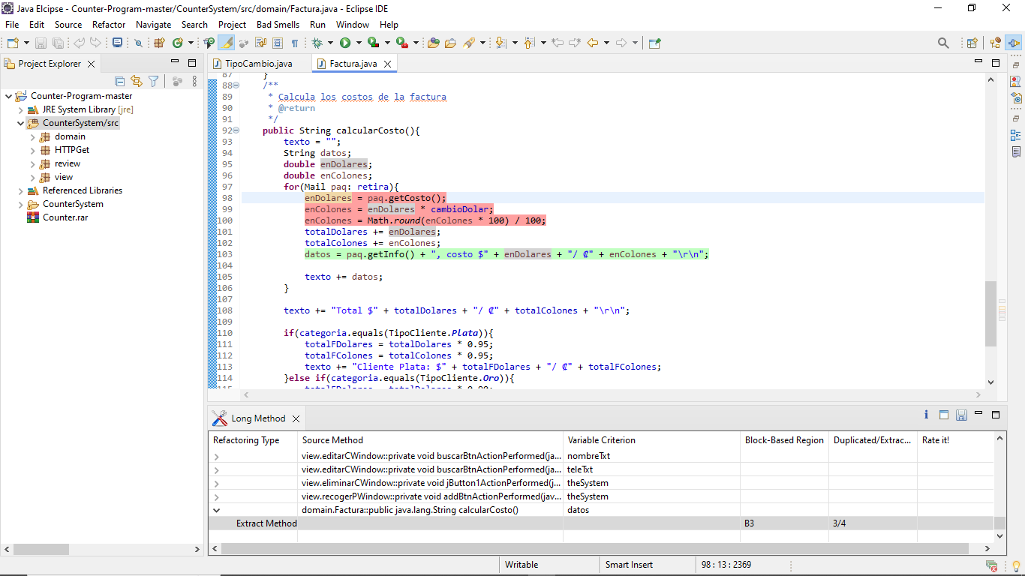

Figure 21 Counter program – long method

**Feature Envy**

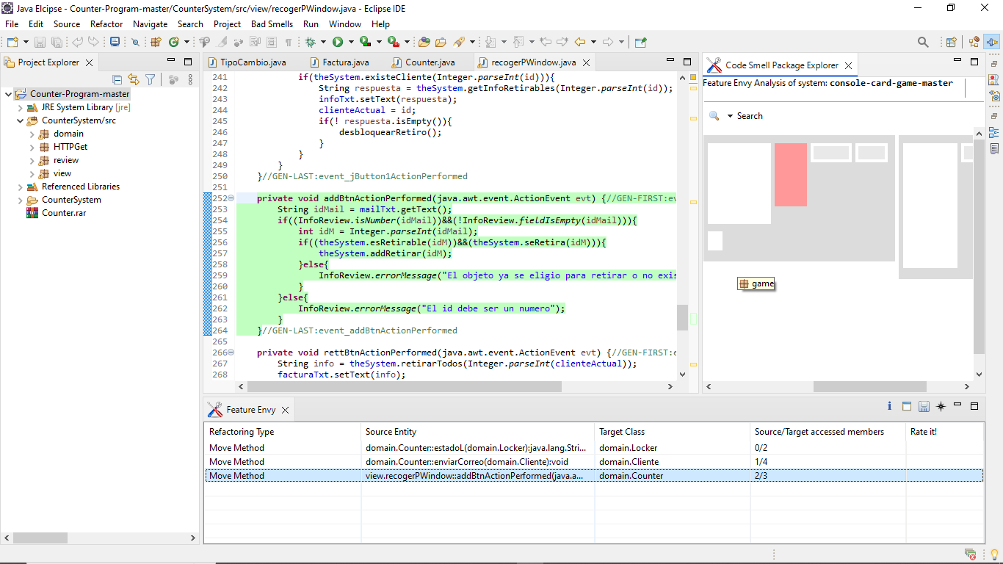

Figure 22 Counter program – feature envy

**9. Project title: Meal management system**

**God Class**

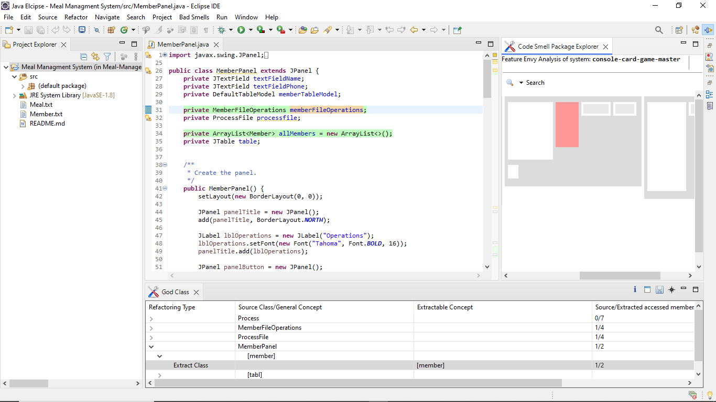

Figure 23 Mean management system – god class

**Long Method**

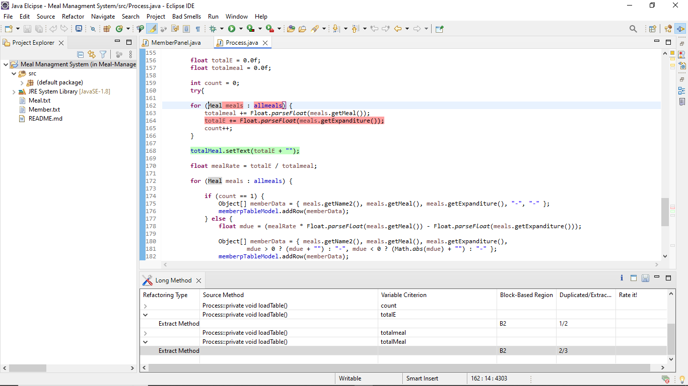

Figure 24 Mean management system – long method

**Feature Envy**

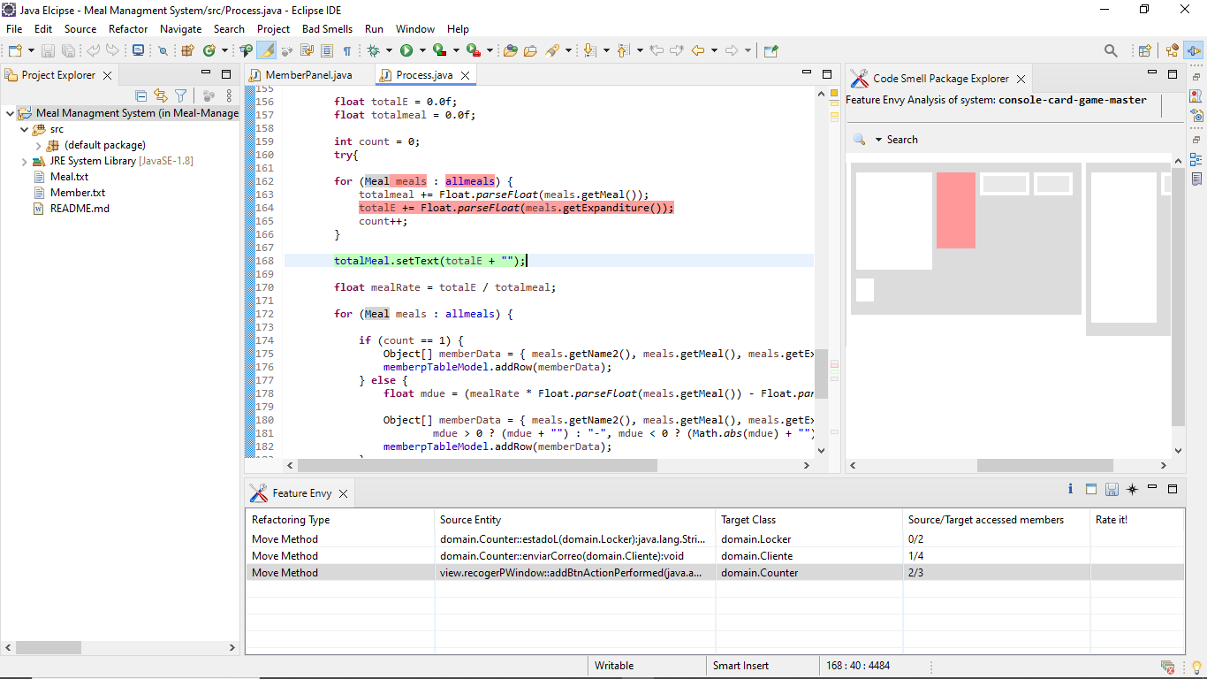

Figure 25 Mean management system – feature envy

**10. Project title: Queue management system**

**God Class**

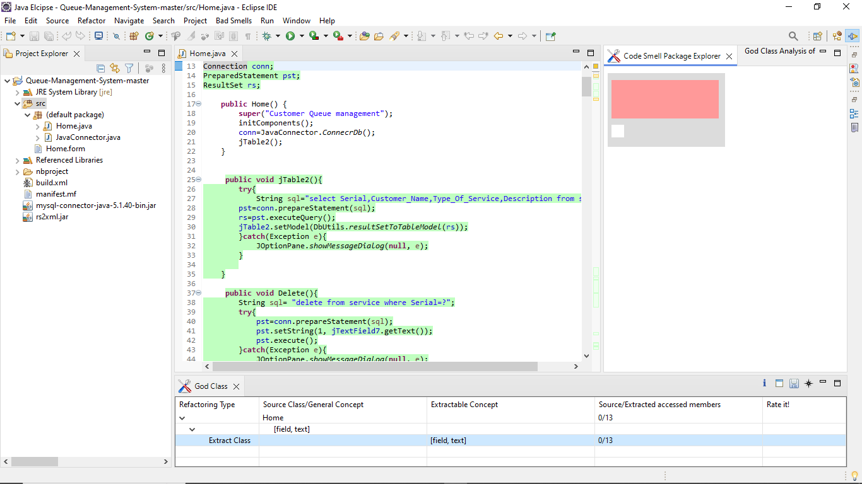

Figure 26 Queue management system – god class

**Long Method**

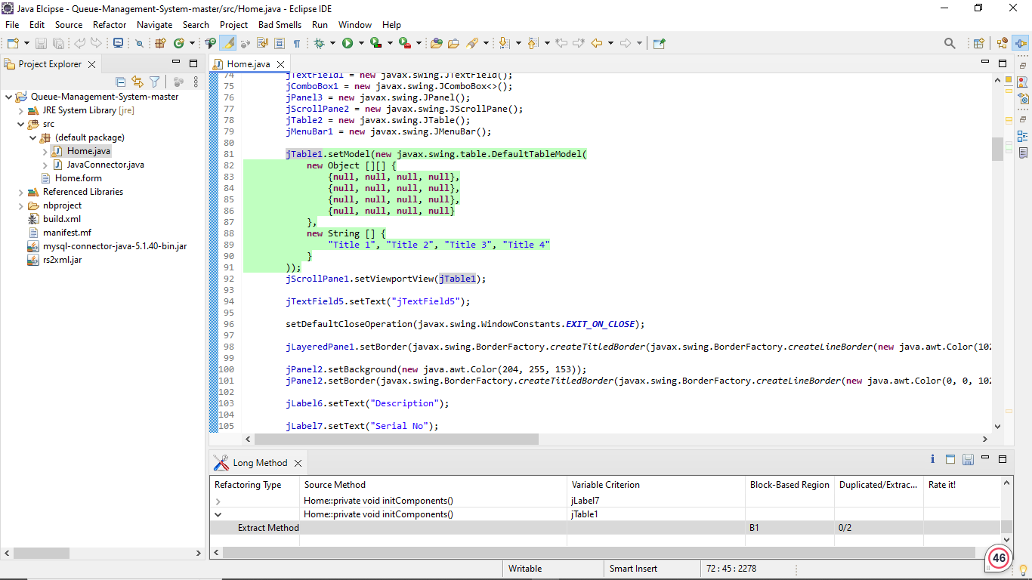

Figure 27 Queue management system – long method

# Section 5:Results and findings

**Result and findings**

The metrics used to measure the testability of the projects are

* CBO
* DIT
* LCOM

CBO (Coupling between Objects) is used to measure the extent of interdependence between the classes in the software system. DIT (Depth of Inheritance Tree) is used to measure the depth of inheritance hierarchy in the software system. LCOM (Lack of Cohesion in Methods) metric is used to measure the absence of cohesion by counting number of disjoint sets which do not share the instance variables.

**Comparison of metrics**

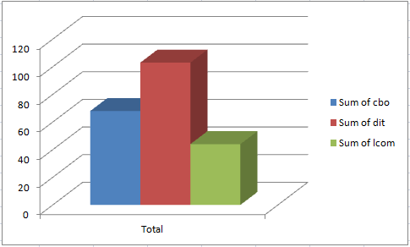

Figure 28 Comparison of the metrics

The average value of CBO metric is high when compared to other metrics.

**Conclusion**

The analysis exhibited proper correlation between the presence of code bad smells and inefficiencies in modularity metrics, particularly in coupling and cohesion. By analyzing modularity metrics for individual classes within the projects, it was easy to find the unique classes which are deviated mainly from the expected modularity standards. The findings exhibit the importance of instantly addressing code bad smells to maintain and improve the modularity of software projects (Aversano, 2020).

# References

Aversano, L. (2020). An Empirical Study on the Evolution of Design Smells. *Mdpi*, 15.

Cairo, A. S. (2020). The Impact of Code Smells on Software Bugs: A Systematic Literature Review. *Mdpi*, 16.

Lacerda, G. S. (2020). Code Smells and Refactoring: A Tertiary Systematic Review of Challenges and Observations. *Journal of Systems and Software*, 1-44.

Mhawish, M. Y. (2020). Predicting Code Smells and Analysis of Predictions: Using Machine Learning Techniques and Software Metrics. *Journal of Computer Science and Technology*, 1428-1445.

Verwijs, C. (2021, December 20). *In-Depth: What Scientific Research Has To Say About Technical Debt And Code Smells*. Retrieved from Medium: https://medium.com/the-liberators/on-technical-debt-and-code-smells-ae8de66f0f8b